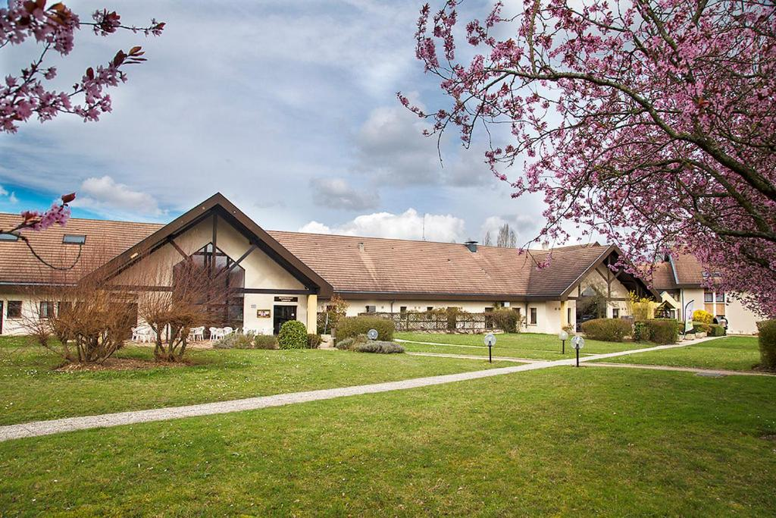**Coach trip to Monet’s Garden organised for Crowborough Rotary Club.**

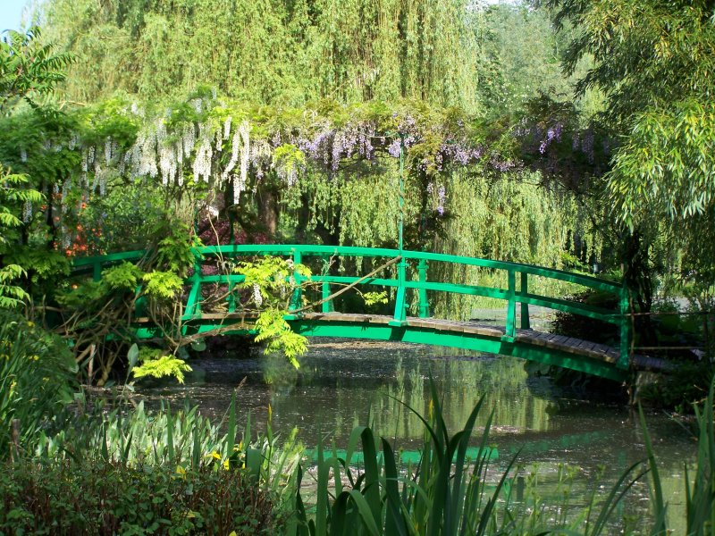



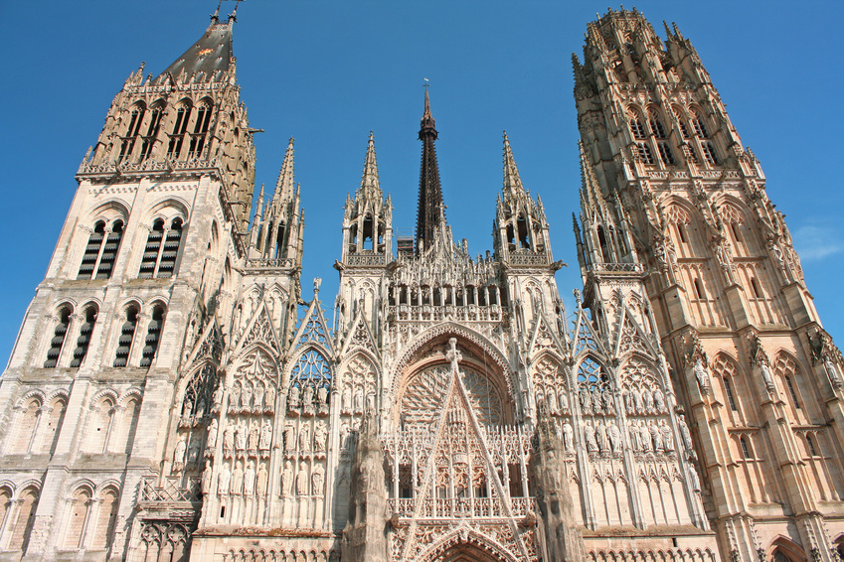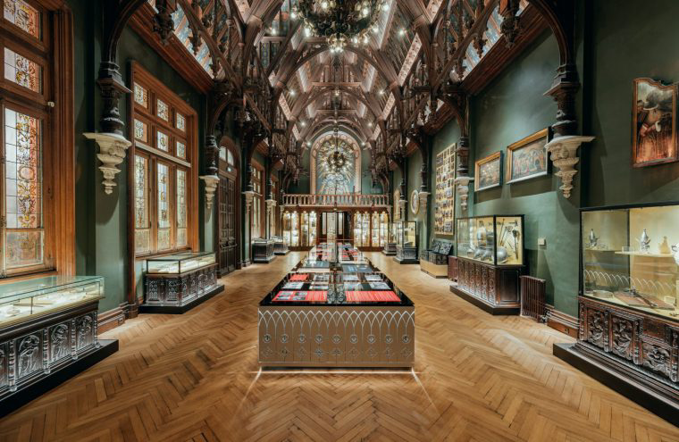

**Itinerary**

**Normandy Tour organised for Crowborough Rotary Club**

**27th-30th May 2025**

**Day 1: Tuesday 27th May**

We pick you up from waitrose Croft Road at 7h30, and once on board our coach, we make our way to Folkestone, where we join the Eurotunnel to Calais. We make our way to Rouen where we have time for sightseeing & refreshments. We continue to our hotel arriving early evening.

**Day 2: Wednesday 28th May**

This morning, we leave the hotel after breakfast and we visit Claude Monet’s House & Garden, where we have included a guided tour, we visit his famous studio and explore the water garden. We have time to walk to one of the local restaurants in Giverny, before we make our way to Le Verger de Giverny cider farm, where we have an included tour and tasting. We return to the hotel with time to freshen up before dinner.

**Day 3**: **Thursday 29th May**

Today we visit Caen. Here we explore World War II, the D-Day landings, the Cold War, and Europe's history at the Memorial Museum in Caen. Early afternoon is free in the town, before we depart and visit Carrefour Tourville La Riviere with time for shopping. We return to your hotel in time for dinner.

**Day 4: Friday 30th May**

Leaving our hotel after breakfast, we make our way to Palais Benedictine Museum & Distillery. After a walk round the art collection, join your guide to discover the distillery, the cellars, and attend a tasting. We re-board and make our way back to Calais, enjoying our packed lunch en-route, where we join the Eurotunnel back to Folkestone. We arrive in the local area early evening.

**Further information:**

Vehicle 49 seat executive tour coach with toilet and tea/coffee facilities

Pick up 7.30 am Waitrose, Croft Road, Crowborough

Returning Date 30th May early evening

Duration 4 days

Destination Normandy

Hotel 3* Hotel Restaurant Du Mont Vernon

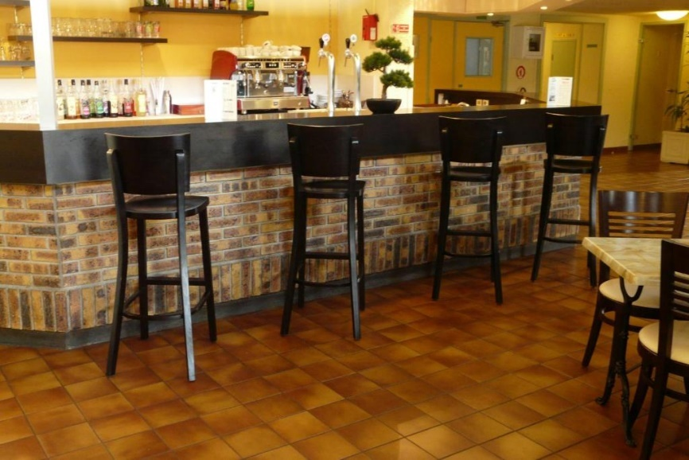Meals Buffet breakfast and buffet evening meal

Excursions As listed above

Total Cost **£591** per person sharing a twin or double room

(Minimum of 30 passengers travelling)

Single room supplement  **£70 = £661**

**Not included: lunches and drinks and insurance.**

Booking your place:

You must call Woods Travel sales department on 01243 868 080 to reserve your place and pay a non-refundable deposit of £100 per person **before** completing and returning your booking form and insurance disclaimer.

This tour includes visits to gardens, stately homes, towns and a distillery. This means that all participants will need to be able to manage some stairs, some walking (possibly on cobbles or uneven ground) and boarding/disembarking of the coach. The hotel does not have a lift, and some rooms are accessible by stairs only.

Insurance

**Woods no longer provide an insurance product. Please note: Everyone must**

**have insurance on holidays for Europe, Isle of Scilly, Channel Islands & Isle of Man.** **Insurance is no longer mandatory on UK holidays, but we would strongly suggest that cover is taken. We are happy to refer you to a local insurance brokers – Robins Row on 01243 841710, quoting Woods when you call.**

Please note that the above cost is based strictly on the number of passengers shown. Should this number not be reached, Woods Travel would have to re-cost the holiday. We must discuss numbers and make our decision at least 12 weeks before departure. Terms and conditions of booking as featured in our 2024/2025 brochure apply. This holiday is sold as a package under the Package Travel Regulations 2018 and is financially bonded by BCH ([www.bch-uk.org](http://www.bch-uk.org)). Our privacy policy can be found on our website ([www.woodstravel.co.uk](http://www.woodstravel.co.uk)).

